[**FIELD-VISIT-BUISNESS-FOR-DIGITAL-MARKETING**](https://github.com/yokesh2522/field-visit-buisness-for-digital-marketing)

1. **INTRODUCTION**
   * + Briefly introduce the concept of digital marketing.
     + Explain the importance of practical experience in digital marketing.
     + Introduce the purpose of the documentary - to explore field visits in the context of digital marketing.
2. **PROBLEM DEFINITION AND DESIGN THINKING**
   1. ***Empathy map***

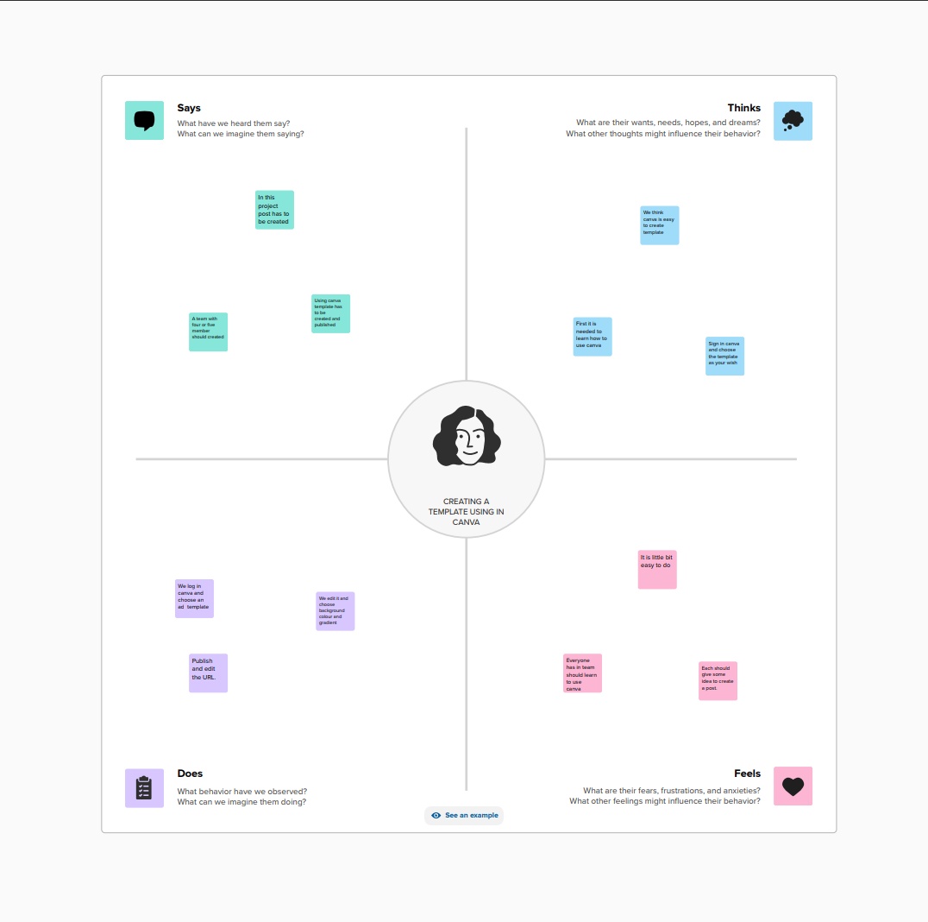

* 1. ***Ideation & Brainstormimg***

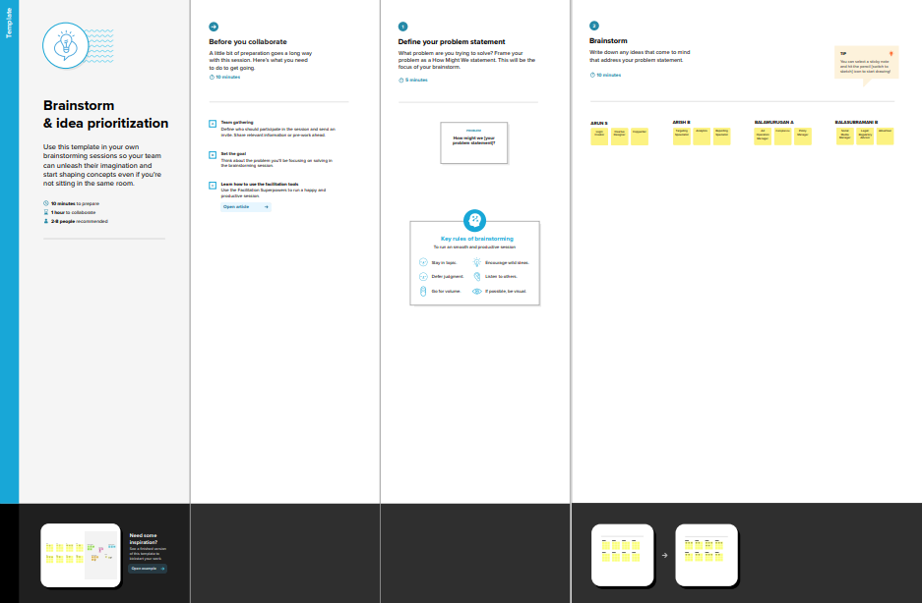

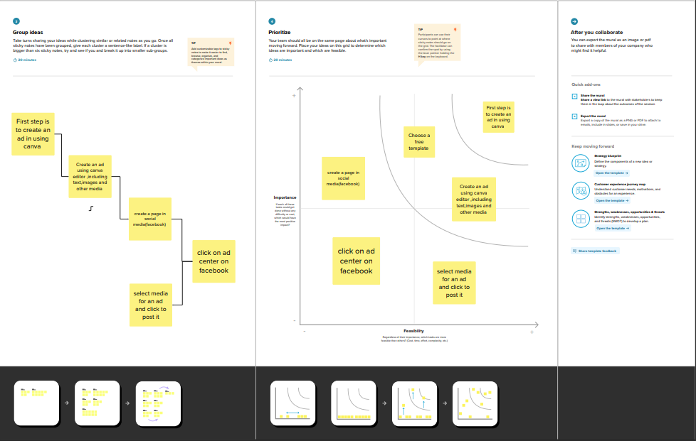

1. **RESULT**

Video demonstration - <https://drive.google.com/file/d/1AxEVLNf4GtBZ_aElSl1PdbENxC0Hz30j/view?usp=sharing>

1. **ADVANTAGES**

* Discuss the benefits of field visits in digital marketing, such as gaining insights into the target audience, understanding market trends, and competitor analysis.
* Show how it can lead to more effective and targeted digital marketing strategies.
* Feature success stories and concrete data to support these advantages.

**DISADVANTAGES**

* + - Explore the potential challenges and drawbacks of field visits in digital marketing.
    - Address issues like cost, time, and the risk of inaccurate data.
    - Include interviews with professionals who have faced and overcome these challenges.

1. **APPLICATION**

* Provide practical tips on how to plan and execute a successful field visit in digital marketing.
* Include interviews with companies or individuals who have successfully integrated field visits into their digital marketing strategies.
* Show the diverse ways field visits can be applied in different digital marketing contexts.

1. **CONCLUSION**

* Summarize the key points discussed throughout the documentary.
* Emphasize the importance of field visits in digital marketing for improving strategies and staying competitive.
* Encourage digital marketers to consider incorporating field visits into their practices.

.